Pledge to walk or wheel in December –take a photo and share it on your social media with #ModeshiftCycleBells.

**Friday 1 December**

**Ring the changes on your school journey**

**Jingle all the way**

**Monday 4**

**December**

It’s time to ring your bike bell, tinkle your scooter bell or jangle the one on your hat and jingle all the way to school!

**Holly Hunt**

Be on the lookout for prickly holly and its beautiful red berries..

**Tuesday**

**5 December**

**Elf Day**

Are you going elf ears, elf hat, elf shoes or full on elf?

**Wednesday**

**6 December**

Jump along in a warm snuggly jumper.

**Christmas Jumper Day**

**Thursday**

**7 December**

**Friday**

**8 December**

**Bikeability Buddies**

Show us your #SeasonalCycleSelfie – a photo or drawing of you and your

friends and family

out cycling.

Use recyclable materials to make you, your bike or scooter sparkle.

**Sustainable Sparkle**

**Monday 11**

**December**

**Go Green**

How many evergreen trees can you spot on your way to school today?

**Tuesday**

**12 December**

Are there any real snowflakes or paper ones in windows?

You could even make your own.

**Spot the Snowflake**

**Wednesday**

**13 December**

Show us your best moves - Get movin’

& groovin’, rockin’ and rollin’ as you walk or wheel to school.

**Christmas Tree Rock**

**Thursday**

**14 December**

Show your friends it’s quicker to walk, cycle and scoot to school.

**Reindeer Race**

**Friday**

**15 December**

How many decorated houses or Christmas lights can you see on your journey?

**Deck the Halls**

**Monday**

**18 December**

Have you spotted

Mr & Mrs Claus on

your school journey yet?

**Santa Rollin’ and Strollin’**

**Tuesday**

**19 December**



Join in with our Cycle Bells song, post your own version or even write a new verse!

**Wednesday**

**20 December**

**Stride and Ride sing along**

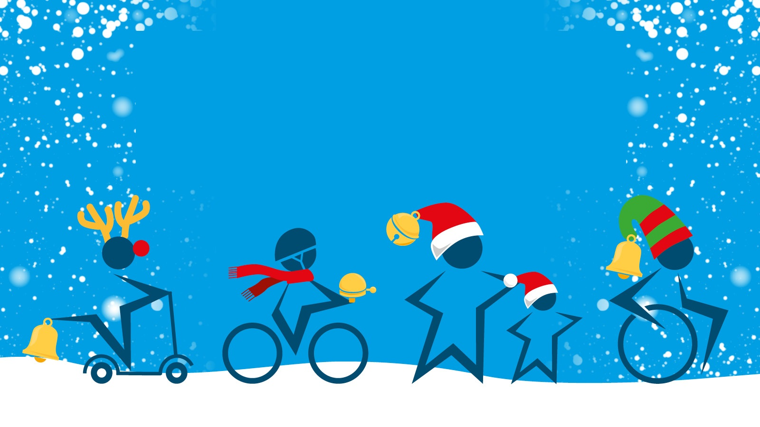

Share a photo montage of your #ModeshiftCycleBells journey with us.

**Celebrate in style**

**Thursday 21 December**