Modeshift Guide for Users

How to view your profile
Once logged in, members can view their profile by clicking on their name or on ‘My Profile’.
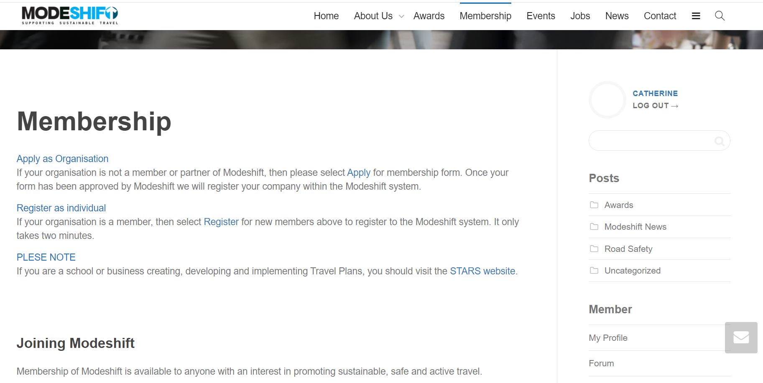

The profile page includes icons to provide access to information that is relevant to you.

Activity logs your recent activity on the Modeshift website
Profile enables you to change your profile picture and edit your details
Notifications show information that relates directly to you
Messages from other members are shown here
Friends include friendship requests that you can accept and a list of contacts
Groups show the organisations that you are associated with on this website
Forums show the comments and interaction on any forums that you have engaged in

How to connect with Friends
We encourage engagement through the member forums. The latest group discussion and sharing of good practice can be found by clicking on Forums in the member section on the right of the page. We encourage you to get actively involved with discussions where you can add value to other members.
When it is useful to continue discussions on a 1:1 or small group basis, the option to request friends or message other members can be seen below their profile picture. We do not have a list of members for you to find connections.
If you make a friend request, it has to be approved for a connection to be made.

How to Access ‘Members Only’ content
Some articles are accessible to the public, but most content is restricted, so only members have access.
The content is categorised to help filter your search. Click on Awards, News or the relevant category to see the latest posts.
Forums and Groups can only be accessed by members
Details of upcoming events and recently listed member vacancies are accessed through the main menu.
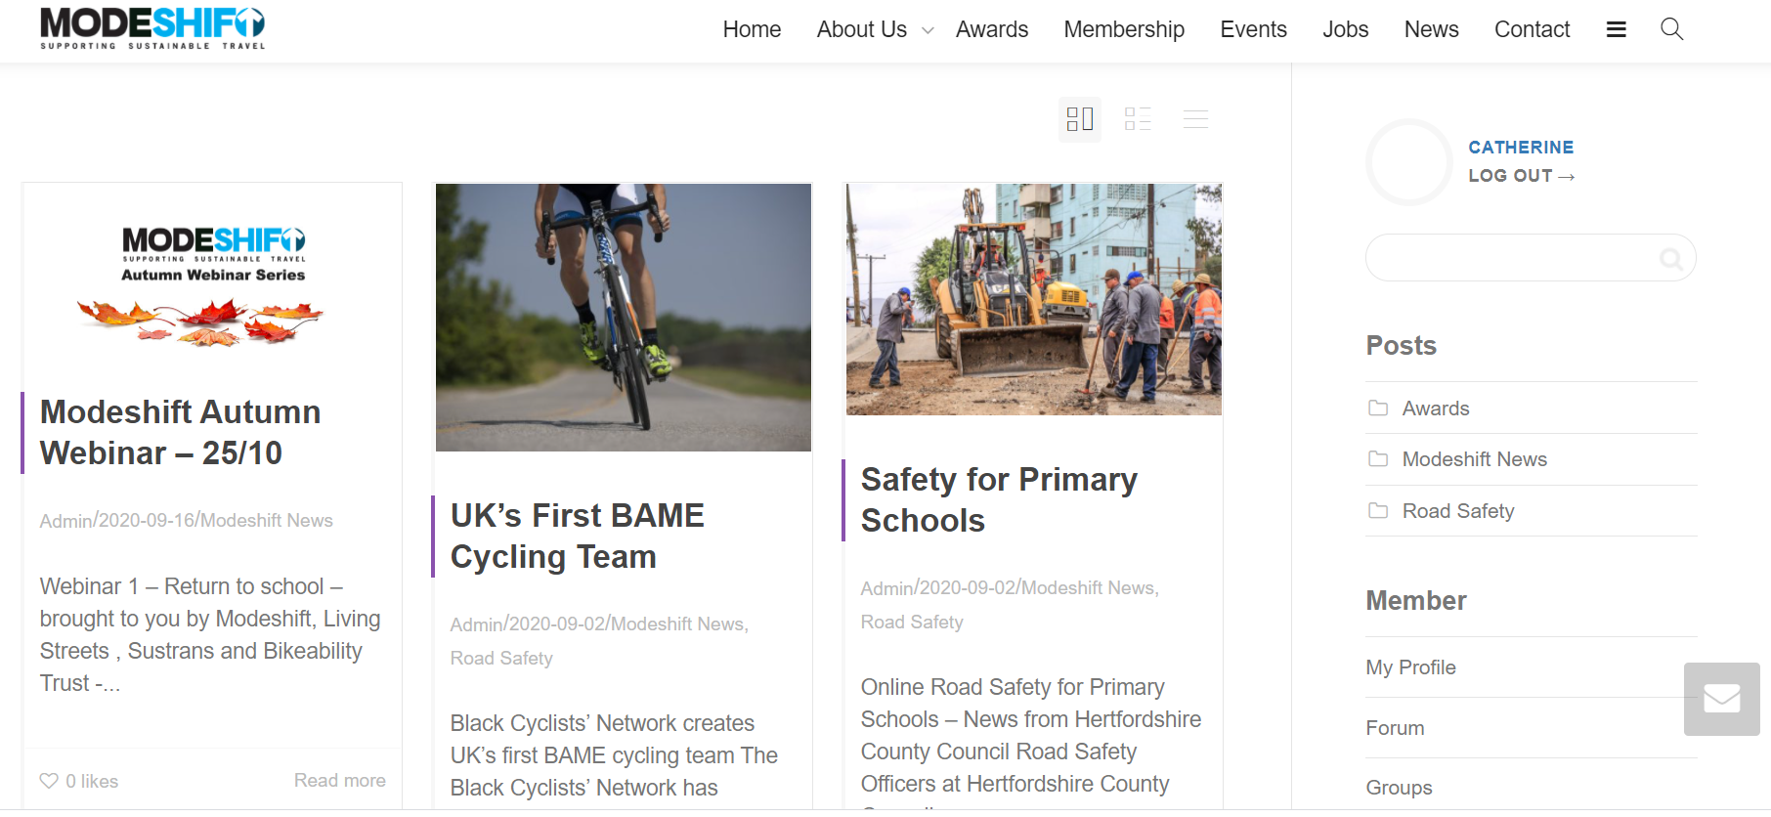

Sharing Information
Our site is compliant with GDPR. Even members cannot access information about other organisations and individuals without their consent.

